**Database Management Project**

**Gym Management System**

**Project’s problem**

Managing gym memberships and creating personalized training programs efficiently is a challenge for gyms using manual or outdated systems.

Our project aims to develop a system that automates gym membership management, improving payment tracking, scheduling, and facility usage. This solution will enhance user experience and provide valuable analytics for gym owners.

**ER Diagram:**

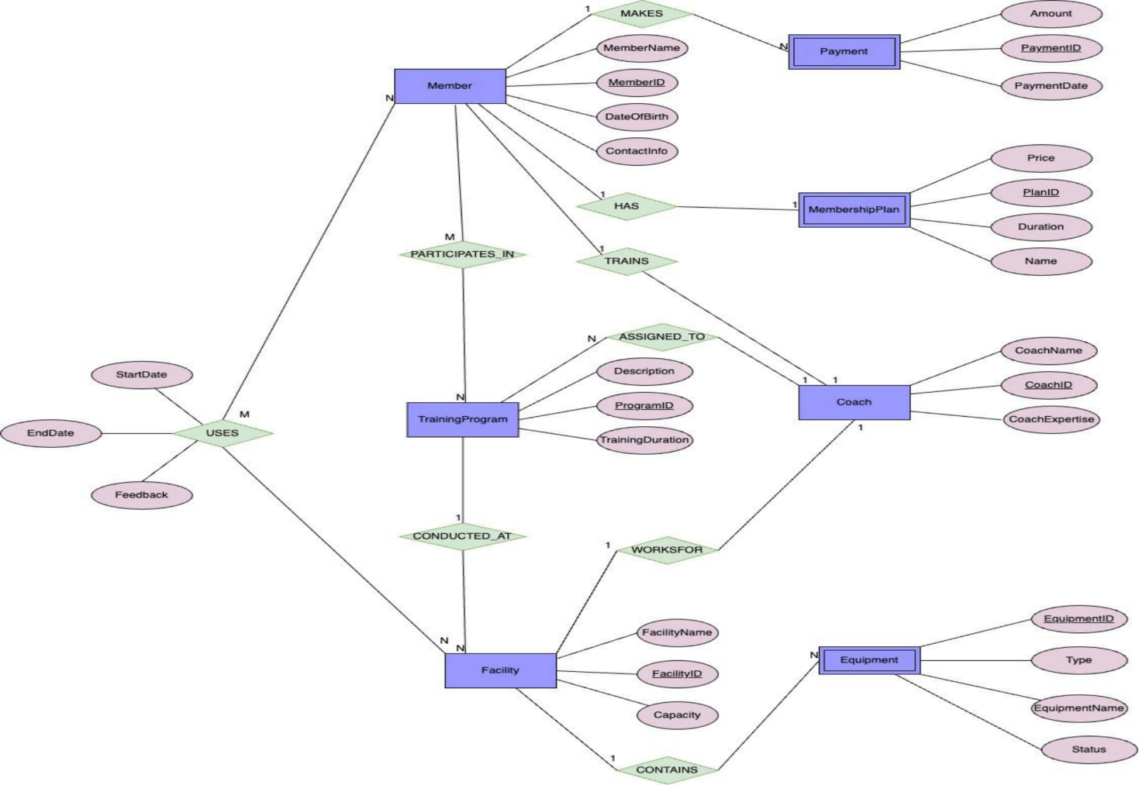

**Part 1: Database Schema**

Tables: The schema defines several tables including Member, Payment, MembershipPlan, Coach, Facility, and TrainingProgram. Each table has relevant attributes (columns) to store information about members, payments, plans, coaches, facilities, and training programs.

Relationships: The schema doesn't explicitly define relationships between tables using foreign keys. However, the queries in later parts imply relationships like a member having a payment, a plan having a price, and a coach having expertise.

